# NM2207

Week 1

# Challenges

# Navigating files and folders

Step 1. Make sure you have Chrome installed. If not, you can download it here.: [https://www.google.com/chrome/](http://www.google.com/chrome/)

Step 2. Download and install the sublime text editor. You will find it here: <http://www.sublimetext.com/>

A note on directory (“folder”) structure:

Directories are structured as “trees” with a name or letter for the root of a disk on your system. Here is a picture of such a tree (Windows Explorer and Mac Finder both have tree views):

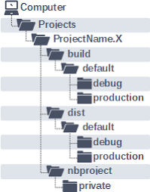

If you click on a particular directory, it “opens” and you are “in” it.

Step 3. Open a (Explorer or Finder) window on your file system. Navigate to a location where you will do all your development for this class, and create a new folder (or “directory – same thing!). Let’s refer to it as nm2207dir (but you can name it whatever you want)

Go to Documents and create a new folder there called nm2207dir.

Step 4. Open a command line window (Command Window / Terminal) on your machine and navigate to the folder you just created using “cd”.

Eg, type “cd Documents/nm2207dir” (without the quotes)

What is this?

cd = change directory

Documents/nm2207dir = path of the directory you want to go to.

There are a couple of different ways to specify directories using text. One by typing out the “full path”, for example

* + cd C:/Documents/nm2207dir/Session01.class/

and another is by using a “relative path” from the directory you are “in”. So if you are already in nm2207dir you could refer to the dist folder simply as

* + cd Session01.class

since it is located in the directory you are already in.

Paths are useful not just for “cd” but for everything, including adding scripts, or even photos, to your web application or web site.

Step 5. It is very important to master the basics of file navigation and command line usage, and to keep a nice clean directory structure for your class work code along, homeworks, and final project. Let’s practice using the command line:

1. print the name of the directory you are in.\
2. navigate to nm2207dir using the command line specifying the relative path.
3. navigate back up to the “parent directory” using “cd ..”
4. navigate back to nm2207 specifying the full path (either by typing it manually, or by dragging that folder from Explorer/Finder on the command window after typing ‘cd ’.

Command line commands for your reference:

1. “foo” and “bar” are example names of **directories**. You can call yours something else. Directories mean the same thing as folders. They are used interchangeably.
2. “foofile” and “barfile” are example names of **files**. You can call yours something else.
3. The command in brackets and a question mark e.g., (ls?) means “What happens when you try this command?”
4. Avoid creating names with space in them “my.file” is better than “my file”!

|  |  |  |
| --- | --- | --- |
|  | **MAC & Linux** | **WINDOWS (DOS)** |
| Navaigate to a file path | cd fullfilepath | cd fullfilepath |
| Show files in folder | ls | dir (ls?) |
| Make a directory | mkdir foo | mkdir foo |
| Change directory to foo | cd foo | cd foo |
| Make a directory | mkdir bar | mkdir bar |
| Show files in folder | ls | dir (ls?) |
| Change to child directory ie bar from foo | cd bar | cd bar |
| (. means this directory, .. means the “parent”  directory) |  |  |
| Change to parent directory ie foo from bar | cd .. | cd .. |
| Create a new file called foofile.html (first confirm that you are in the foo directory) | code ./foofile.html  (Follow instructions at the bottom of <https://nm2207.org/creativeweb/Setup.html> to get this to work properly) | code ./foofile.html  (Follow instructions at the bottom of <https://nm2207.org/creativeweb/Setup.html> to get this to work properly) |
| Show files in folder | ls | dir (ls?) |
| Delete file | rm foofile.html | del foofile.html |
| Copy a file to a directory | cp foofile.html bar | copy (cp ?) foofile.html bar |
| Move a file to a directory | mv foofile.html bar | move (mv?) foofile.html bar |
| Delete a directory foo | rmdir foo | rmdir foo |
| Show contents of text files on screen | cat foofile.html (less foo) | type foofile.html |
| Open an text file which is in the same directory in a browser | open ./foofile.html | foofile.html |
| Open a text file which is in one level up directory in the browser | open ../foofile.html | ../foofile.html |

Tips for the command line:

## You can also drag and drop folders to the command window to print their location. (Try using this to change directories with cd!)

## TAB completes partially typed commands if it can.

# Set up FileZilla

Now we need some program to help us upload our web pages to this machine so that they can be served. We’ll use the “file transfer” (FTP) program FileZilla for that (if you already have an ftp program on your machine you are comfortable with, you don’t need this)

Step 6. Download and install the the FileZilla FTP program. You will find it here: https://filezilla-project.org/

Download the Client (not the Server).

Open FileZilla and enter the hostname (nm2207.org) your userid, password in the fields at the top of the window. The “port” field should be 22.

**Your username is your NUS userid,**

**Your password is Creative…Coding, where “…” is your login id (the one that starts with e0)**

**Port is 22**

The port is kind of the phone number at which the server is listening for new connections.

The window on the right will open in your home directory on nm2207.org. Navigate to your ‘web’ folder. ***Anything you put in this folder will be visible on the web.***

***Note:*** *never delete or replace the web folder itself – only do that for files and folder inside web/*

(Don’t close FileZilla yet)

Now, you can use FileZilla to upload the folders that have your homework in them from your **local** machine to your home directory on nm2207.org.

Step 7. Open a browser and navigate it to: <https://nm2207.org/2223S2/e0775370/web/>

Does it work? Important: Why or why not? Discuss with your partners to make sure you understand what is happening.

Step 8. Navigate your browser to your neighbor’s home page, too!

Step 9. On FileZilla, rightclick and rename the index.html file in your web folder to index_original.html. Now, navigate the left side window so that it shows the folder you have been working on and the files within it. Now, drag your newly-created index.html file there from your local folder.

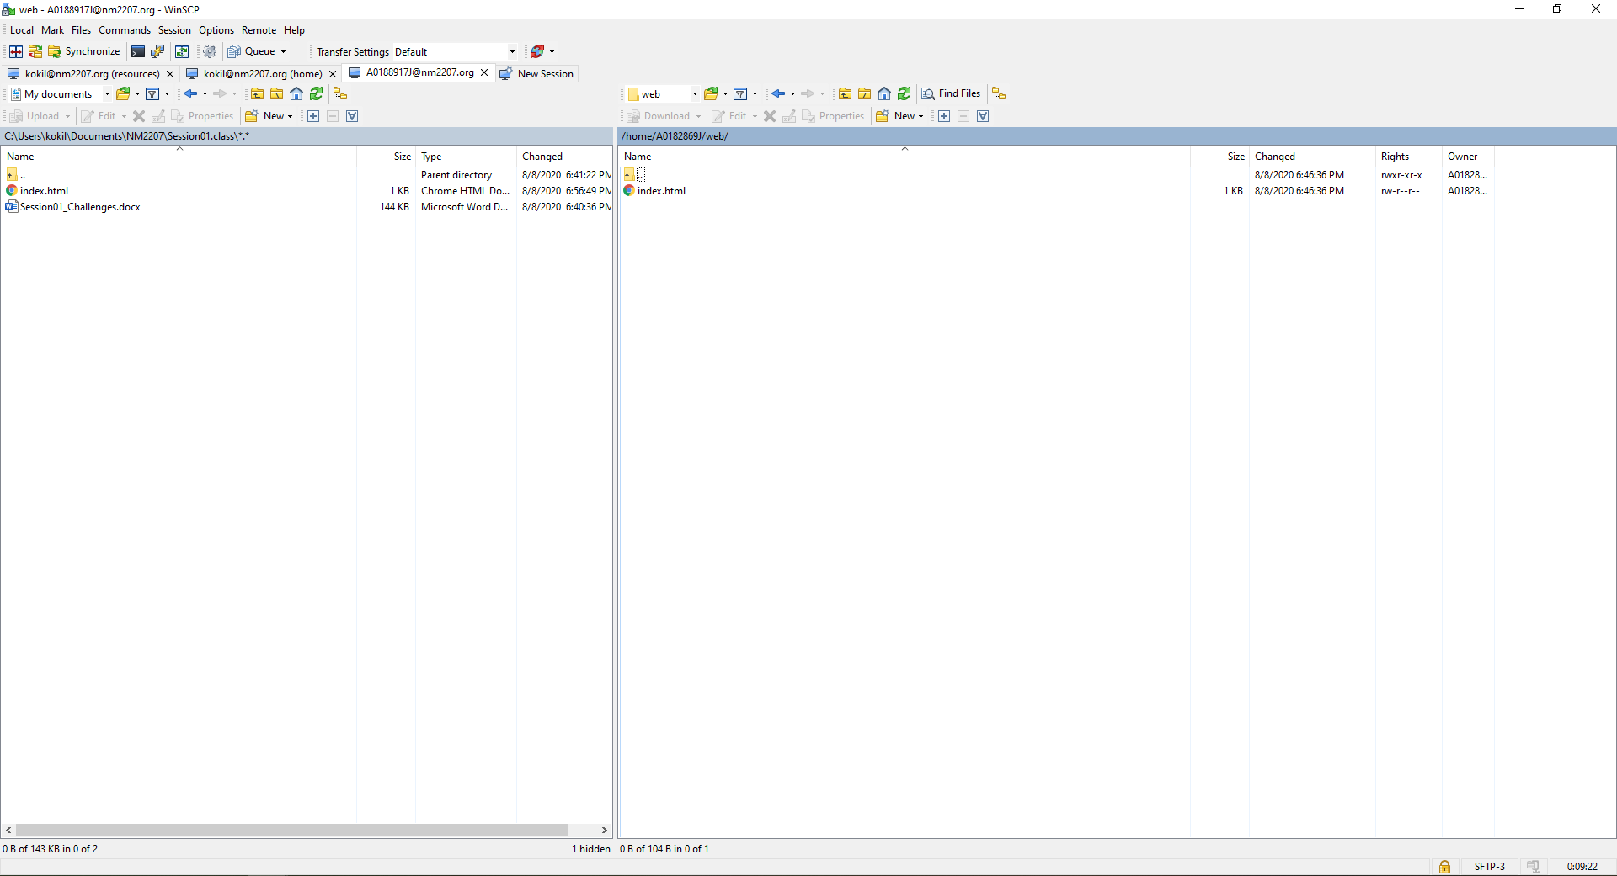

# Practising Pseudocode

# Easy: Write a flowchart and pseudo-code that reads two numbers and multiplies them together and prints out their product

# *Flowchart:*

# *Start -> Multiply = 0 -> Input num1, num2 -> Multi = num1*num2 -> Print answer -> Stop*

# *Pseudo-code:*

# *Step 1: Start*

# *// Declare variables*

# *Step 2: multi =0*

# *// Input values*

# *Step 3: Input num1, num2*

# *// Perform multiplication*

# *Step 4: multi = num1*num2*

# *// Print the answer*

# *Step 5: Print multiplication*

# *Step 6: Stop*

# Medium: Write a flowchart and pseudo code that performs the following:

# • Ask a user to enter a number. If the number is between 0 and 10, write the word blue.

# • If the number is between 10 and 20, write the word red.

# • if the number is between 20 and 30, write the word green.

# • If it is any other number, write that it is not a correct color option.

# *Step 1: Start*

# *Step 2: let num*

# *Step 3: Input num*

# *Step 4: if(num>0 && num<10) {go to Step 5} else {go to Step 6}*

# *Step 5: {print(“blue”)} {go to Step 12}*

# *Step 6: if(10<num<20) {go to step 7} else {go to Step 8}*

# *Step 7: {print(“red”)} {go to Step 12}*

# *Step 8: if(20<num<30) {go to Step 9} else {go to Step 10}*

# *Step 9: {print(“green”)} {go to Step 12}*

# *Step 10: if(num>30) {go to Step 11}*

# *Step 11: {print(“it is not a correct color option”)} {go to Step 12}*

# *Step 12: Stop*

# Write a flowchart and pseudo code to print all multiples of 5 between 1 and 100 (including both 1 and 100).

# *Step 1: Start*

# *Step 2: Num = 0*

# *Step 3: num = num + 1*

# *Step 4: if(num%5==0) {go to Step 6;} else {go to Step 5}*

# *\*is this num a multiple of 5? if yes go to Step 6, otherwise go to Step 5\**

# *Step 5: if(num<=100) {go to Step 3} else {go to Step 7}*

# *\*still less of equal to 100? if yes go to Step 3 otherwise go to Step 7\**

# *Step 6: Print num {go to Step 3}*

# *Step 7: Stop.*

# Extra: Changing your password

Now lets try to connect to nm2207 using the command prompt.

It will be painful as always. Buckle up!

**Connection: just pinging the nm2207 server but not logging in**

From an open terminal/command window on your local machine, type

* ping nm2207.org
* if the nm2207.org machine is “alive,” ping will report on how long the machine takes to respond to the repeated pings
* Ctl-C will stop the incessant pinging

**Logging into nm2207.org**

For Windows users only, you will need a program for opening terminal windows on a remote machine:

Window users only:

Download PuTTY https://[www.chiark.greenend.org.uk/~sgtatham/putty/latest.html](http://www.chiark.greenend.org.uk/~sgtatham/putty/latest.html) the MSI (‘Windows Installer), 64 bit, is the one you want.

You know that you have an account on this machine, so lets log in through the command line now.

Your username is your NUS userid,

Your password is Creative…Coding, where “…” is your userid

So log on:

* Mac users use a terminal window and :
* ssh [userid@nm2207.org](mailto:userid@nm2207.org)
* (you’ll be prompted for your password)
* Windows users:

Run PuTTY

type nm2207.org as the Host Name (IP address) You’ll be prompted for your userid and password

**Understand this please:** You now have a window open on nm2207.org. Anything you do runs **on that machine** (not on your local machine)!

**Change your password**

The first thing you should do when you log on to your new account on nm2207.org is **change your password**. Please make it hard to guess, but easy for you to remember! To change your password, use this command :

* passwd

Navigate to your home directory and list its contents

Your window is open on your home directory on nm2207.org, and you can type bash commands (see the **Bash Shell Cheat Sheet** on our Class Resources site (https://nm2207.org/creativeweb/) for a reminder of some of the basics). You can see the contents of your home directory with

* ls

To exit your session when you are done on nm2207.org, just type exit at the command prompt:

* exit